Fortismere School

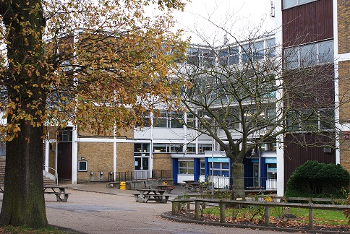

Fortismere School is a high achieving, mixed, foundation secondary school in Muswell Hill, North London. The 2017-18 season is our 3rd season of Vex and 2nd season of Vex EDR. During our first ever season of vex in the Vex IQ Bankshot challenge we managed to qualify for the world finals in Kentucky however were unable to attend due to funding issues. In our second year, (last season) we started our first two Vex EDR teams and once again had great success managing to secure second place for skills in all the UK and having large success in the UK nationals - making it all the way to the quarter finals.



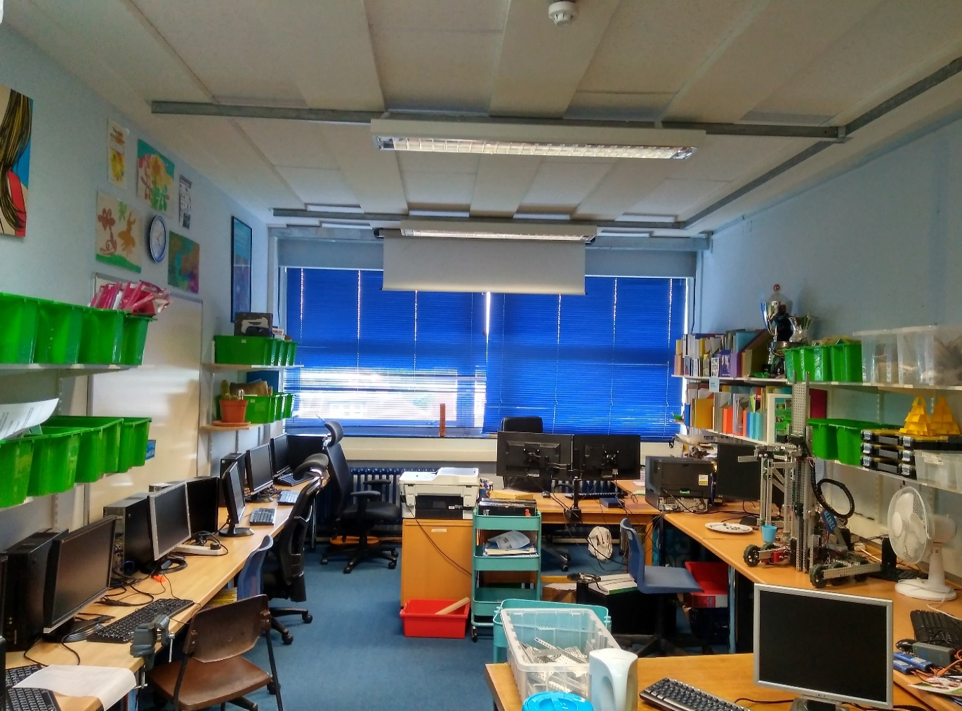

Most of the robot construction takes place here, in the Vex workshop and computing office. Our team members come during break, lunch, free periods, and after school to work on the robots resulting in a constant work-flow. We have all the different materials and tools sorted into various storage methods around the workshop, allowing for easy access and at the same time keeping the room tidy.

Meet the Staff

# Mr M Yakup Lead Mentor/Coach

# 

Mr Yakup is head of Enterprise at Fortismere, encompassing ICT, DT, Economics and Business, each of which are extremely useful skills to have in regards to the competition. Mr Yakup is very dedicated, spending lots of his own time after school and on weekends ensuring we have everything we need and we all are taken to competitions safely.

He acts as a great role model, offering tips and advice whenever needed.

# Mr B Ovayolu Programming Mentor

# Image result for empty profile picture

For whoever comes with us to a comp

# Robert Buxton Project lead

Meet the team members

# 

Robbie is extremely dedicated to the team, often staying late to make sure everything is going to plan. He is a good leader, who can happily listen to ideas, but is also decisive in important matters to ensure a good compromise is reached.

Robbie has experience across all fields so makes an ideal leader; he has an understanding of everything that goes on to do with the Robot.

# Samuel Poirier Engineering lead

# 

Sam has experience with robotics outside of Vex – using Raspberry Pis and soldering his own wiring to make simple robots, which helps not only with overall design and construction of the robot, but for repairing mechanisms after inevitable damage!

Sam is the go to person if you need help with something, software or hardware.

# Felix Black Engineer

# 

With nearly 900 hours in Factorio, Felix is considered a master at optimising machinery. He has the dedication to fine-tune the robot, and can quickly make additions and changes.

Felix specialises in prototyping new mechanisms for the robot, enabling concepts to be tested before they are implemented, ensuring everything is at optimum performance before it is added to the main body.

# Joshua Hudson Software Engineer

# 

Josh has thousands of hours working in programming languages varying from C++ to JavaScript. He brings his experience to the Vex team allowing us to utilize complex systems like PID control and differential steering, dramatically raising the performance and efficiency of our robot. He is also adept at implementing sensors within the program, ensuring that the robot performs its actions precisely.

# James Tomlin Manager

# 

Although not the most glamorous of jobs, Jim ensures that all the parts that the engineers require have been purchased, as well as keeping an overall tally of the resources. This is vital as it makes sure that money is not wasted on duplicate parts, and unnecessary delays are avoided.

Jim also acts as an organiser for competitions so that no matches are missed and alliances are discussed before the final picking of teams.

Event timeline

This season we plan to attend as many events as we can. This is for obvious reasons such as giving a higher chance to qualify for nationals and give us more practice. However due to fact that we plan to attend so many events we need to close eye on our build schedule as we do not want to turn up to an event with a robot that does not function to it greatest potential. Below we have decided to make a timeline showing us when all the events are and how long we have between each of them to work on improving the robot. We hope to constantly update this document until the end of the season.

Our source for competition information is robot events: [www.robotevents.com](http://www.robotevents.com)

|  |  |  |  |  |
| --- | --- | --- | --- | --- |
| Date | Name | Attending /Attended | Number of teams | Excellence Available |
| **19/06/17** | First build session |  |  |  |
| 103 days |  |  |  |  |
| **30/09/17** | In The Zone Hertfordshire Regional | Yes | 24 | No |
| 6 days |  |  |  |  |
| **06/10/17** | King Henry VIII, Coventry Regional | Maybe | 24 | No |
| 51 days |  |  |  |  |
| **26/11/17** | Hertfordshire VRC Tournament | Yes | 16 | No |
| 9 days |  |  |  |  |
| **05/12/17** | South East London In the Zone Regional | Maybe | 16 | No |
| 1 day |  |  |  |  |
| **06/12/17** | In The Zone North West Regional | Maybe | 20 | No |
| 2 days |  |  |  |  |
| **08/12/17** | In The Zone North London Regional | Maybe | 16 | No |
| **08/12/17** | HBS VEX In The Zone – North London Regional | Maybe | 16 | No |
| 34 days |  |  |  |  |
| **11/01/18** | W.Yorkshire In The Zone Regional | Maybe | 16 | No |
| 2 days |  |  |  |  |
| **13/01/18** | 2018 Welwyn VEX Robotics Regional – VRC | Maybe | 32 | Probably |
| 3 days |  |  |  |  |
| **16/01/18** | Essex In The Zone Regional | Maybe | 24 | No |
| 3 days |  |  |  |  |
| **19/01/18** | North East VRC “In The Zone” Regional Qualifier | Maybe | 24 | No |
| 1 day |  |  |  |  |
| **20/01/18** | VEX In The Zone – Nottingham Regional | Maybe | 20 | No |
| 1 day |  |  |  |  |
| **31/01/18** | Vex Robotics Stowe Regional (UK teams only) | Yes | 30 | Probably |
| 16 days |  |  |  |  |
| **16/02/18** | South Yorkshire In The Zone Regional | Maybe | 16 | No |
| 14 days |  |  |  |  |
| **02/03/18** | The VEX UK National Championship 2018 | Hopefully | 60 | Yes |
| 54 days |  |  |  |  |
| **25/04/18** | The VEX World Championship 2018 | Hopefully | 600 | Yes |

Last Updated: 28/08/2017

**Early-Season:**

30/09/17 – 26/11/17 = 56 days

**Mid-Season:**

08/12/17 – 11/01/18 = 34 days

**Late-Season:**

N/A

**Post nations:**

02/03/18 – 25/04/18 = 54 days

Look at this timeline we can work out several useful things. The first thing is the amount of time we should build the robot before the first competition which is 103 days. This number will be useful as we can use it to make a build schedule. The second useful information which we can grasp from this document is density of the competition and what time would be the best to do a rebuild if we need too. Looking at the schedule we can detriment that the events are all quite concentrated however there are a few gaps where we could squeeze in a rebuild. Looking at the schedule we can see the best times to rebuild are early-season and mid-season (there is also post nationals however this is only important if you are going to worlds) so we will have a large review of our robots at that time and decide whether or not rebuilding is a good idea.

## Best times to rebuild

# Analysis

|  |  |  |  |
| --- | --- | --- | --- |
| Milestone | Target Date | Date Hit | Time Difference |
| First build session | 19/06/17 |  |  |
| Complete Base | 08/07/17 | 28/06/17 | -10 days |
| Complete Lift | 27/07/17 | 17/07/17 | -10 days |
| Complete Claw | 15/08/17 | 04/08/17 | -11 days |
| Finish Tweaking | 05/09/17 |  |  |
| Finish Programming and testing | 20/09/17 |  |  |
| First Comp | 30/09/17 |  |  |

Build schedule 19/06/17 – 30/09/17

Do this after we program

# Evaluation

**Last Updated:** 30/08/2017

After creating our build schedule, we worked out that we have 103 days from our first build session to our first competition. We decided to use this information to try and make a project timeline so we can use our limited time the most effectively. We have 5 main milestones which all need to hit before the first comp. We plan to program our robot after we get back to school on the 05/09/17 as the summer holidays are soon coming up. In the summer holidays, we have set four milestones of which we have equally allocated 19 days to try and complete. As we hit milestones we will input the date we hit them into the table allowing as to work out if we are on/ahead or behind schedule.

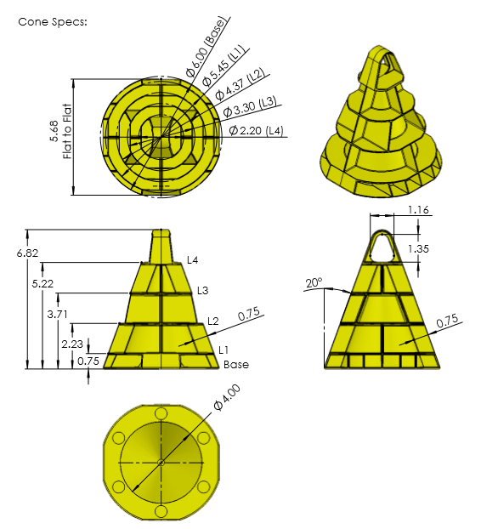Cones

The Cone object is without a doubt the most important object in “In the Zone”. Being a cone it is a somewhat awkward in shape. We predict that the two main methods of gripping will either be by grabbing it with a claw type device or lifting it using a rod slid through the eye. Another important factor to consider is that it is possible for cones to be knocked over. This means that designs will need to be able incorporate a separate (or perhaps integrated) method for picking up fallen cones.

Measurement on diagrams in inches

**Height:** 17.32 cm / 6.82"

**Width:**  15.24 cm / 6.00"

**Weight:** 118g ± 10%

**Amount:** 80

* 1 Preload
* 12 match loads
* 52 field

**Points:** 2

**Extra info:**

* Has a 3.43 cm eye
* Can be stacked

Mobile Goals

*Measurements on diagrams in inches*

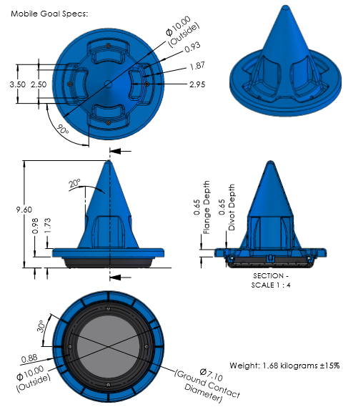

The Mobile Goal is crucial to scoring in the game “In the Zone”. Cones are scored by being stacked upon the mobile goal or the stationary goal. Being the used in the primary method of scoring it is important that our robot need to be able to grasp and move it. Like the cones, they are also prone to being knocked over, although it is arguably much harder to do due to its weight and low centre of mass. This means that the robot needs to be able to self-right the mobile goal to have any chance of succeeding

**Height:** 24.38 cm / 9.60"

**Width:**  25.40 cm / 10.00"

**Weight:** 1.68kg ± 15%

**Amount:** 8

* 4 red
* 4 blue

**Points:**

* 20 far zone
* 10 middle zone
* 5 close zone

**Extra info:**

* Cones can be stacked upon it

Stationary Goals

*Measurements on diagrams in inches*

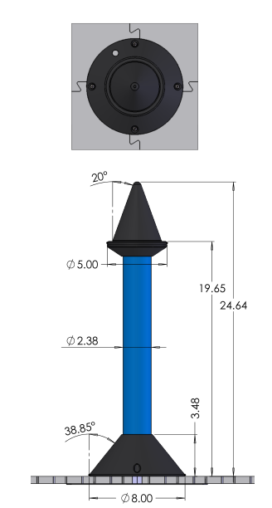

**Height:** 62.59 cm / 24.64"

**Width:**  20.32 cm / 8.00"

**Weight:** N/A

**Amount:** 2

* 1 red
* 1 blue

**Points:** N/A

**Extra info:**

* Cones can be stacked upon it
* Static

The Stationary Goals serve the same function as mobile goals with the only different being they are static and cannot be scored. Because of the singularity of their nature, starting height and immobility we suspect the stationary goals will be last goal that teams stack.

Stacking

*Measurements on diagrams in inches*

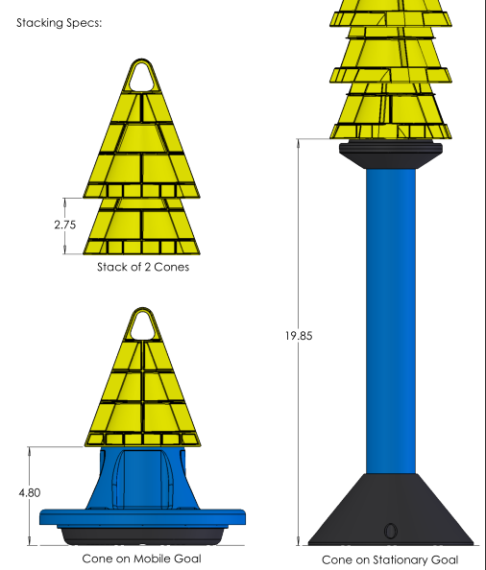

**Stationary Goal:**

19.85" + (n-1 * 2.75")

Mobile Goals give an elevation of 12.92cm / 4.80"

Stationary Goals give an elevation of 50.42cm / 19.85"

Stacked Cones give an elevation of 7.00cm / 2.75"

**Mobile Goal:**

4.80" + (n-1 * 2.75")

Table for heights of stacks

|  |  |  |  |  |  |
| --- | --- | --- | --- | --- | --- |
| Number of cones | Height on Mobile Goal(inches) | Height on Mobile Goal(cm) | Weight (pounds) | Weight (kg) | Height on Stationary Goal (inches) |
| 1 | 11.8 | 30.0 | 4.0 | 1.8 | 26.9 |
| 2 | 14.6 | 37.0 | 4.2 | 1.9 | 29.6 |
| 3 | 17.3 | 43.9 | 4.5 | 2.0 | 32.4 |
| 4 | 20.1 | 51.0 | 4.7 | 2.1 | 35.1 |
| 5 | 22.8 | 57.9 | 5.0 | 2.3 | 37.9 |
| 6 | 25.6 | 65.0 | 5.3 | 2.4 | 40.6 |
| 7 | 28.3 | 71.9 | 5.5 | 2.5 | 43.4 |
| 8 | 31.1 | 79.0 | 5.8 | 2.6 | 46.1 |
| 9 | 33.8 | 85.9 | 6.0 | 2.7 | 48.9 |
| 10 | 36.6 | 93.0 | 6.3 | 2.9 | 51.6 |
| 11 | 39.3 | 99.8 | 6.6 | 3.0 | 54.4 |
| 12 | 42.1 | 106.9 | 6.8 | 3.1 | 57.1 |
| 13 | 44.8 | 113.8 | 7.1 | 3.2 | 59.9 |
| 14 | 47.6 | 120.9 | 7.3 | 3.3 | 62.6 |
| 15 | 50.3 | 127.8 | 7.6 | 3.4 | 65.4 |
| 16 | 53.1 | 134.9 | 7.9 | 3.6 | 68.1 |
| 17 | 55.8 | 141.7 | 8.1 | 3.7 | 70.9 |
| 18 | 58.6 | 148.8 | 8.4 | 3.8 | 73.6 |
| 19 | 61.3 | 155.7 | 8.6 | 3.9 | 76.4 |
| 20 | 64.1 | 162.8 | 8.9 | 4.0 | 79.1 |
| 21 | 66.8 | 169.7 | 9.2 | 4.2 | 81.9 |
| 22 | 69.6 | 176.8 | 9.4 | 4.3 | 84.6 |
| 23 | 72.3 | 183.6 | 9.7 | 4.4 | 87.4 |
| 24 | 75.1 | 190.8 | 9.9 | 4.5 | 90.1 |
| 25 | 77.8 | 197.6 | 10.2 | 4.6 | 92.9 |

Point breakdown:

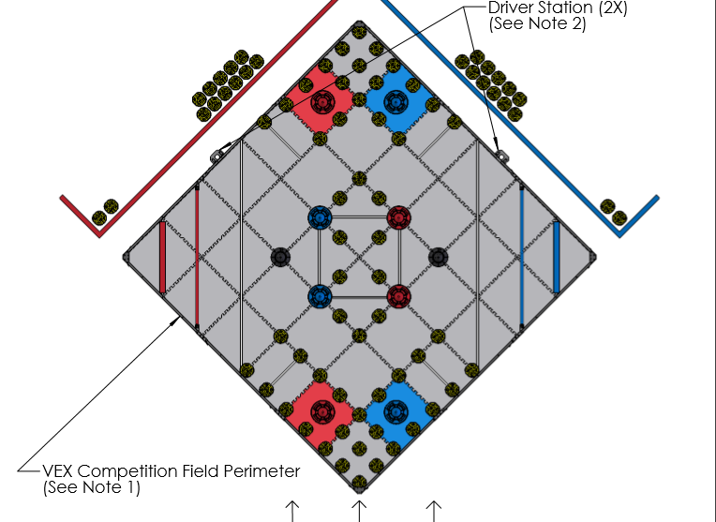

Point Breakdown

# Max points in equal division

**Max points when field cones are split between two teams**

**Autonomous:** 10pt

**Win:** 10

**Cones:** 160pt

**On field: (**26*2) * (2)

**Preload: (**2*2) * (2)

**Driver Load: (**12*2) * (2)

**Mobile goals:** 50pt

**20pt Zone:** 1*(20)

**10pt Zone:** 3* (10)

**Highest stack:** 15pt

**20pt Zone:** 5

**10pt Zone:** 5

**Stationary Goal:** 5

**Park Bonus**: 4pt

**Team square:** 2*(2)

***Total:*** *239*

# Max possible points

**Theoretical – due to opposition this is impossible.**

**Autonomous:** 10pt

**Win:** 10

**Cones:** 80pt

**On Field:** 26 * (2)

**Preload**: 2 * (2)

**Driver load:** 12 * (2)

**Mobile goals:** 50pt

**20pt Zone:** 1*(20)

**10pt Zone:** 3* (10)

**Highest stack:** 15pt

**20pt Zone:** 5

**10pt Zone:** 5

**Stationary Goal:** 5

**Park Bonus**: 4pt

**Team square:** 2*(2)

***Total:*** *159*

**Note:** It is not worth the effort of putting a Mobile Goal in the 5pt zone as assuming you get highest stack in the 5pt zone 50% of the time it is only worth 7.5 points compared to putting in the 10-point stack where it is always worth 10 points.

## Target: 159pt

By looking at the high score breakdown we have decided our score target for the end of the season is 159pt

|  |  |  |  |  |  |  |
| --- | --- | --- | --- | --- | --- | --- |
| **Category** | **Name** | **Individual points** | **Amount** | **Overall points** | **Percentage** | **Difficulty** |
| Autonomous | Win | 10 | 1 | 10 | 06.29% |  |
| Cones | On Field | 2 | 26 | 52 | 32.70% |  |
| Preload | 2 | 2 | 4 | 02.52% |  |
| Driver Load | 2 | 12 | 24 | 15.09% |  |
| Mobile Goal | 20pt Zone | 20 | 1 | 20 | 12.58% |  |
| 10pt Zone | 10 | 3 | 30 | 18.87% |  |
| Highest Stack | 20pt Zone | 5 | 1 | 5 | 03.14% |  |
| 10pt Zone | 5 | 1 | 5 | 03.14% |  |
| Static Goal | 5 | 1 | 5 | 03.14% |  |
| Park Bonus | Team square | 2 | 2 | 4 | 02.52% |  |
| **Total** | **Everything** |  |  | **159** | **100%** |  |
| Autonomous | Total | 10 | 1 | 10 | 06.29% |  |
| Cones | Total | 2 | 40 | 80 | 50.31% |  |
| Mobile Goal | Total |  |  | 50 | 31.45% |  |
| Highest Stack | Total | 5 | 3 | 15 | 09.43% |  |
| Park Bonus | Total | 2 | 2 | 4 | 02.52% |  |

Looking at the statistics above we can see scoring mobiles goals is the easiest way to score a high amount of points. Being relatively easy to score and making up 31.45% of the average max points scoring cones is an easy way to gain lots of points early in the round. Because of this we think that we will see a lot of robots focusing on just scoring the mobile goals in the first quarter of the season. The parking bonus is also easy to get however since it is only equal to 2.52% of points it is negligible. The autonomous bonus and highest stack bonus are depended on the skill level opposite team it has no static difficulty. Lastly, we come to cones. these are the highest way to score points however in our opinion they are also the hardest. We think that the scoring of cones in the begging will not be worth many points but as time passes and robots improve it will become more of an significant factor In scoring.

# Analysis

Optimum Stack Details

Assuming the optimum stack height is 8 cones that means that the robot will need to be able to lift around 5.8 pounds.

# Optimum stack weight

Assuming we are aiming to score max points average points we would need to score 40 cones. Seeing that there are 5 possible bases to score them on, four mobile and one static base, we work out lowest effective stack height to score max points. 40/5 = 8. So, 8 cones is the ideal amount of cones we want to put on each goal. If we sub 8 in to the height equations we made earlier we can work out that mobile goals would have a height of 31” and the static goal of 46”. Therefore, by looking at this data we can conclude that we should aim for our robot be able to lift to a minimum height of 46”. This may not be achievable in the early season however we should aim to try to be able to get to this height by the end of the season

# Optimum stack height

Robot Design

**Choice:** Aluminium

Between the two metals we decided to use aluminium for most of the frame of the robot. This is because although it have the disadvantage of being expensive the advantages of being both strong and light outweighs this because for this challenge being able to expand upwards quickly is essentially and having a heavy robot would make this significantly harder.

**Pros:**

* Strong
* Cheap

**Cons:**

* Heavy

**Pros:**

* Strong
* Light

**Cons:**

* Expensive

For this robot due to the fact we are a high school team and not a university team (they can 3d print plastic) we are limited to using two different materials for this challenge, Steel and aluminium

### Steel

### Aluminium

## Material for chassis

# General design considerations

The design of a robot for this challenge can be broken down into three main sections. The drive, the lift and manipulator. The robot is lifted to only having one drive however it can have multiple lifts/manipulators if necessary. In this document, we will be going over the different sections of the robot and we evaluate the different designs we can use in each of these sections.

**Choice:** No Pneumatic

For this robot, we have the choice of using either twelve motors or 10 motors and a pneumatics system.

### Pneumatics

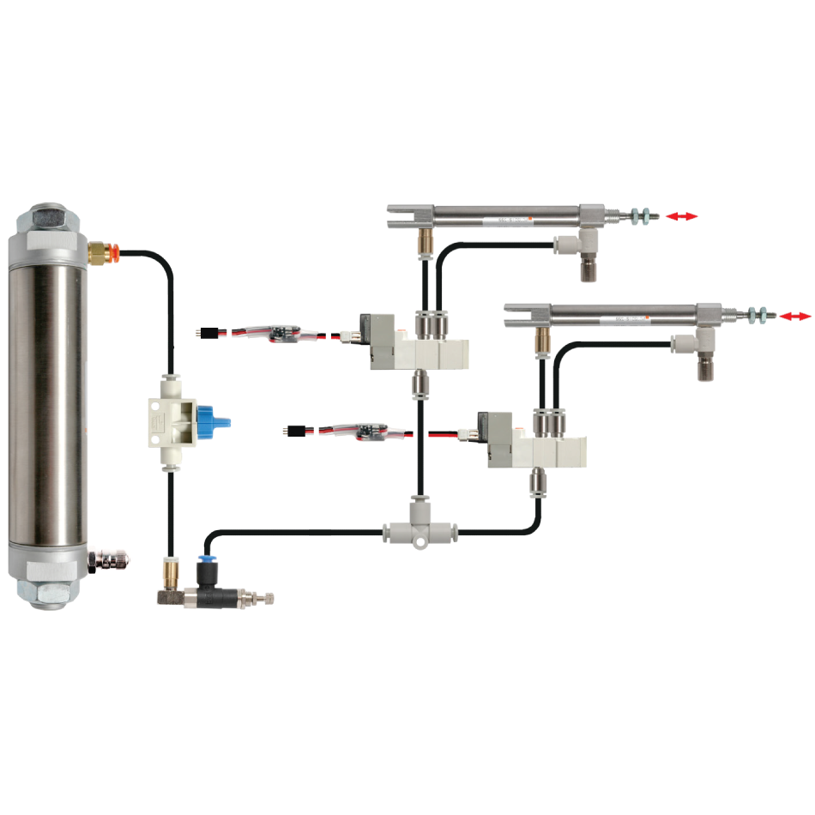

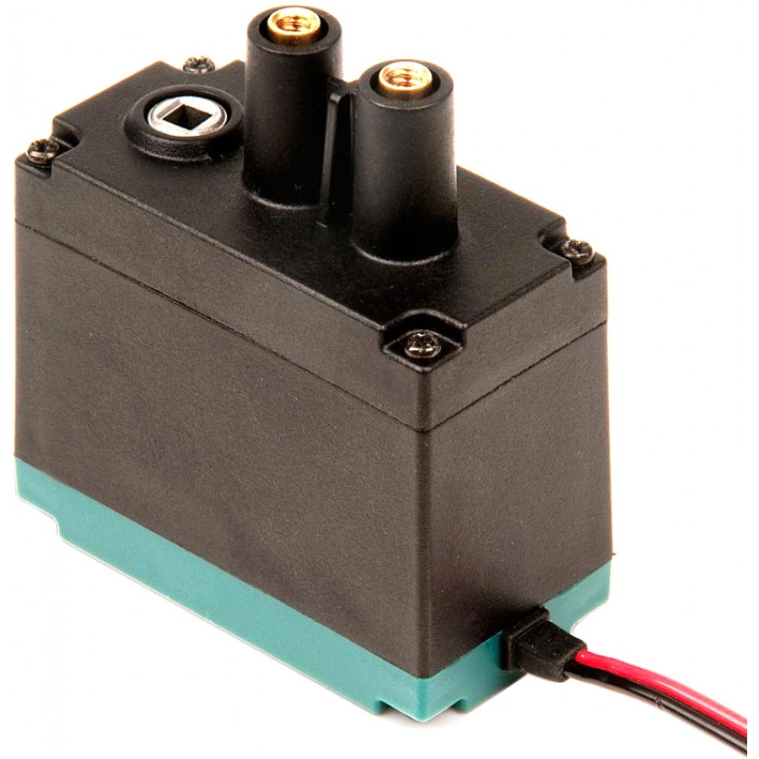

**Pros:**

* Linear motion
* Light

**Cons:**

* Expensive
* Must repump every match

Between the two choices we have decided to go for two extra motor over pneumatics. This is not because we think that using motors is better it is just that at this moment we do not feel the benefits of being light and having linear motion justify the high price tag that they currently have. If we do end up purchasing them in the future we will probably use them on our robot.

**Pros:**

* Stronger
* Cheaper
* Reliable

**Cons:**

* Heavy
* Nonlinear motion

### No Pneumatics

## Pneumatics

When building a drive there are a few different wheel types to pick from. We want a wheel that has good traction but also allows smooth movement.

## Wheel type

# Drive design considerations

### Traction wheel

### Omni wheels

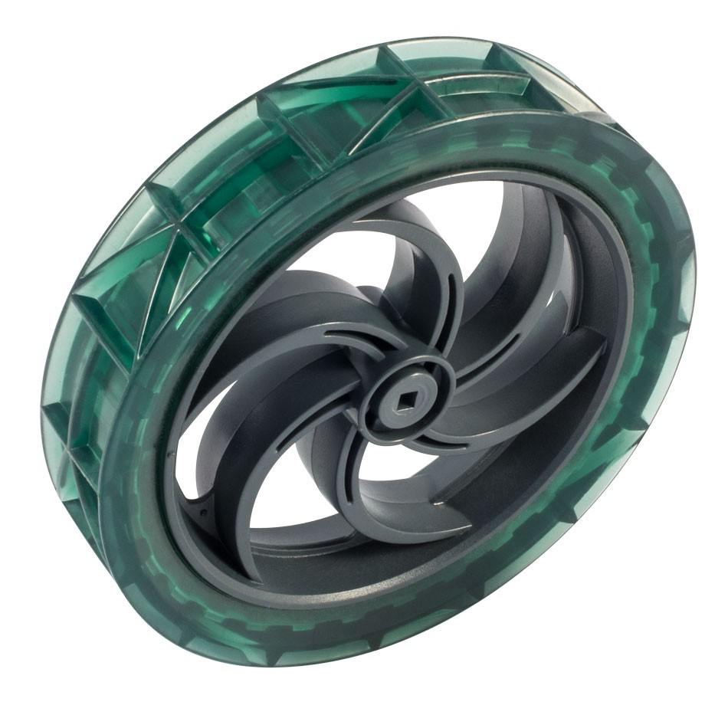

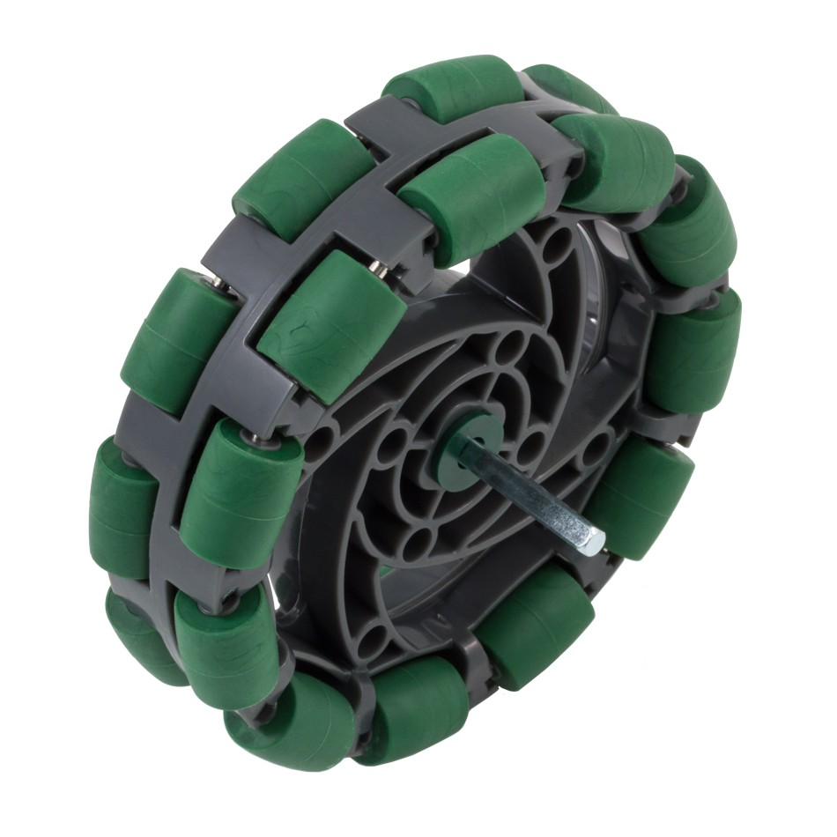

**Pros:**

* Cheap
* Reliable
* High traction
* No internal friction

**Cons:**

* 1 axis of movement

**Pros:**

* Cheap
* 2 axis of movement

**Cons:**

* Less traction

### Mecanum wheels

Between the three different wheels we have decided to use a mixture of omni wheels and traction wheels. Most likely two traction wheels at the front and two omni wheels at the back. The reason for this is that we can use the traction wheels at the front to get over the first bar into the 10-point zone and we can use the omni wheels at the back to have low friction turning. We are not using Mecanum wheels because they are inferior in every way to omni wheels.

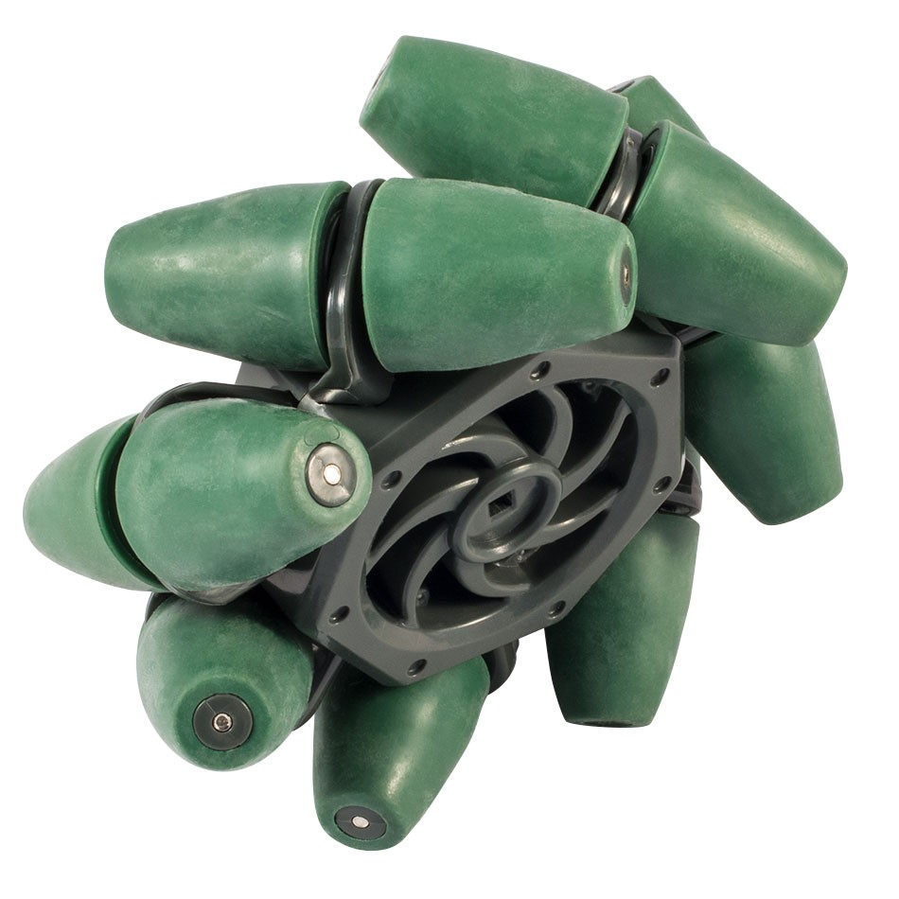

**Choice:** Omni and traction wheels

**Pros:**

* 2 axis of movement

**Cons:**

* Less traction
* Expensive
* High Internal friction
* Less grip

When building a drive there are a few different design types. For this robot we something fast but also strong.

## Drive Type

### X drive

### Tank drive

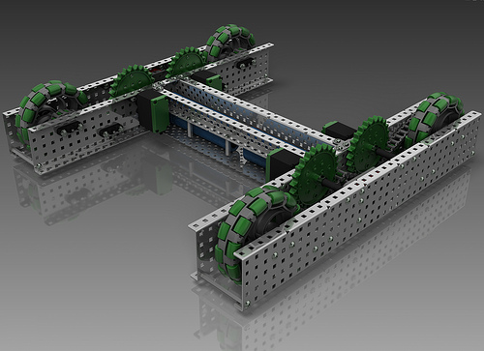

**Pros:**

* Any direction
* Fast
* Even number of motors

**Cons:**

* Weak
* Only multiple of 4 motors
* Complicated to build and program
* Bad at going over things

Between the three different drive types we have chosen to go with the simple tank drive. Although being able to strafe/move in any direction would be incredibly useful when picking up cones and mobile goals we feel that being able to go over the bar is more important and multidirectional drives will struggle with that because of the direction the wheels are facing.

**Choice:** Tank drive

### H drive

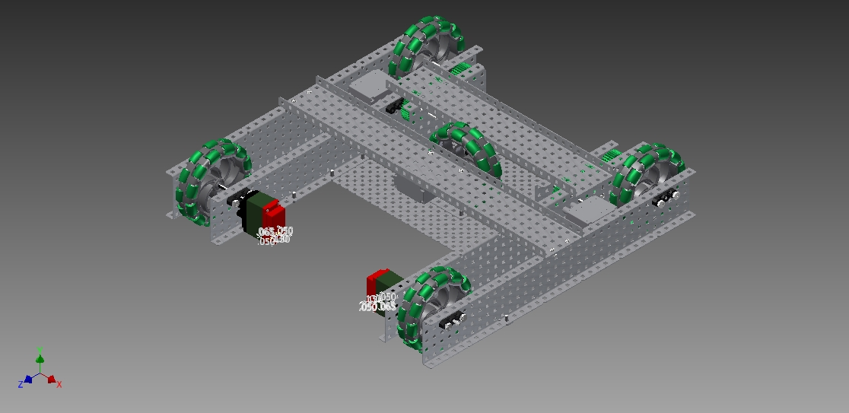

**Pros:**

* Strafe
* Any amount of motors
* Simple

**Cons:**

* Odd number of motors (usually)
* Bad at going over things

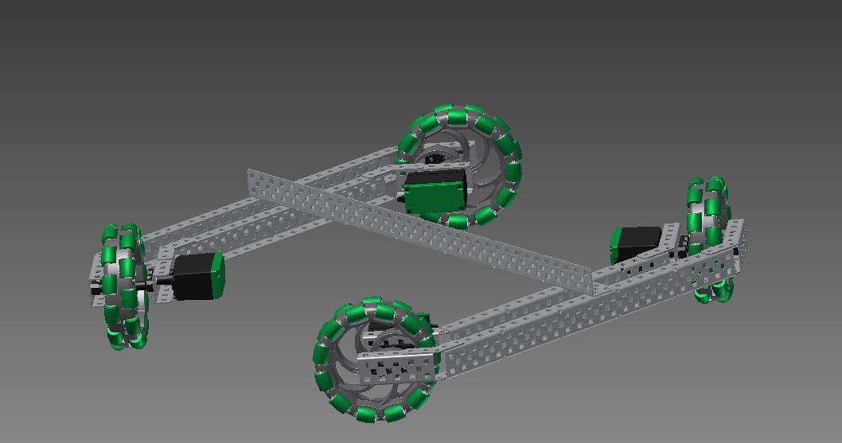

**Pros:**

* Simple
* Any motor amount (multiple of 2)

**Cons:**

* No strafe

## Drive motor gearing and amount

Seeing as we have picked the tank drive we must decide how many and what type of motors we want to use.

### 6 high speed motors

### 4 standard motors



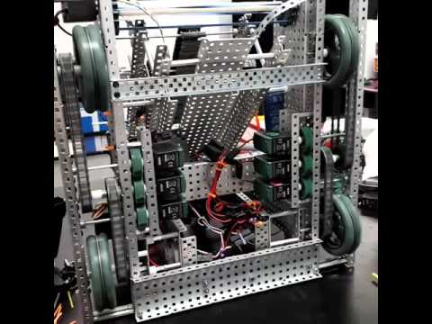

**Choice:** 6 motor high speed

We have picked to use 6 high speed motors on our robot. This is because it is not going to be a self-stacker speed is important, however not important enough to justify using 8 motors.

**Pros:**

* Fast

**Cons:**

* 6 motors



### 8 turbo motors

**Pros:**

* Only 4 motors

**Cons:**

* Slow

**Pros:**

* Really fast

**Cons:**

* 8 motors

## Lift Type

Now what we had picked the drive we must decide what type of lift we want to use. We want something fast and strong that going up in a linear fashion

# Lift design considerations

### Scissor Lift

### Double Reverse 4 Bar (DR4B)

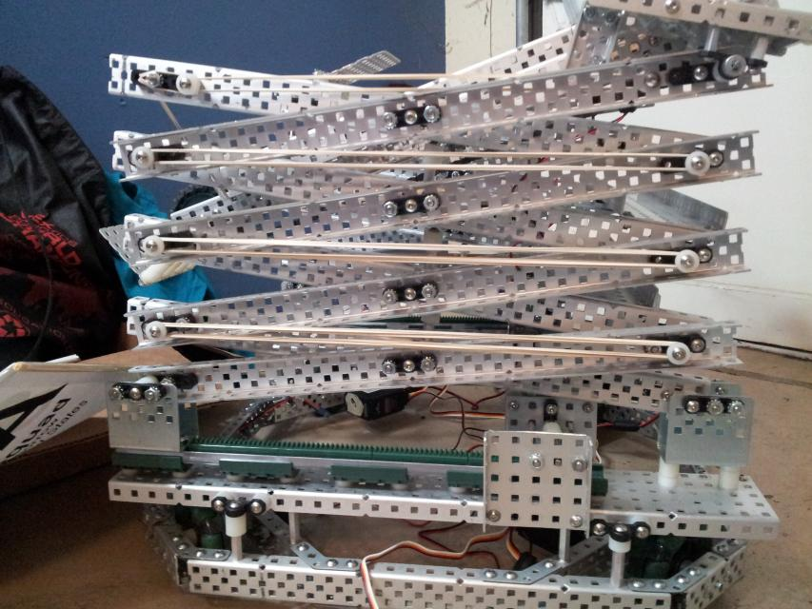

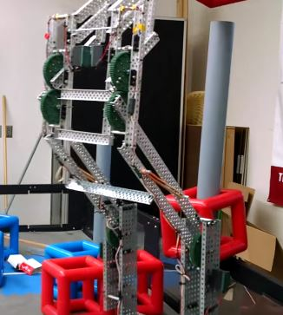

**Pros:**

* Tall
* Vertical motion
* Static motors
* Fast

**Cons:**

* Unstable
* Uses a lot of parts

**Pros:**

* Tall
* Vertical motion
* Fast
* Low friction

**Cons:**

* Not static motors
* Can be flimsy

### Linear lift

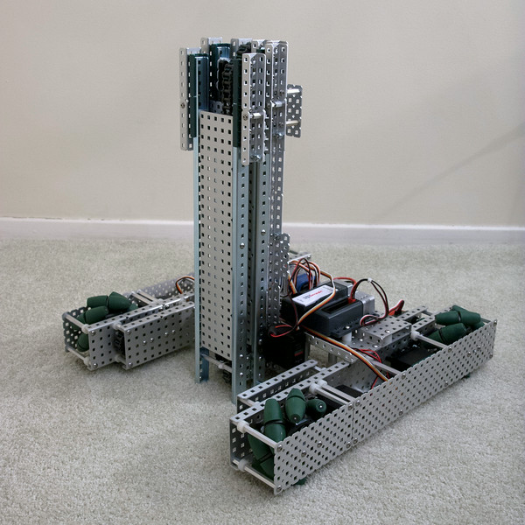

Of the three option we think the two bests are the DR4B and the linear lift. This is because we do not have the parts to build a scissor lift. Between the Linear lift and DR4B we have decided to use the linear lift because it has less downsides and we don’t think the height of the DR4B will really matter in the early season.

**Pros:**

* Vertical motion
* Strong
* Static motors
* Stable
* Fast

**Cons:**

* Chain can snap

**Choice:** Linear lift

### 2 standard motors

**Pros:**

* Only 2 motors

**Cons:**

* Low lift strength

### 4 standard motors

**Pros:**

1. High lift strength

**Cons:**

* 4 motors

### 6 standard motors

**Pros:**

* Really high lift strength

**Cons:**

* 6 motors

We have picked 4 standard motors because we feel that 2 motors would not provide enough torque to lift the mobile goal and 6 motors would provide significantly more than we need and the chain would break at that point anyway making it redundant.

**Choice:** 4 standard motors

## Drive motor gearing and amount

Seeing as we have picked the tank drive we must decide how many and what type of motors we want to use.

We have to decide whether our robot will stack inside itself or outside itself.

## Internal vs External stacking

### External stacker

### Internal stacker

**Pros:**

* Simple
* Another robot can add to your stack

**Cons:**

* Complicated
* Inefficient
* Open to being blocked by other robots

**Pros:**

* Faster
* Does not need to move as much
* Protected

**Cons:**

* Complicated
* Other robots cannot add to your stack

We have picked to stack externally. This is not because we think it is better rather because a linear lift cannot internally stack without adding a rotating element which significantly makes the lift worse.

**Choice:** External Stacker

**Pros:**

* No motors
* No wires to claw

**Cons:**

* Can’t pick up mobile goals
* Unreliable
* Weak

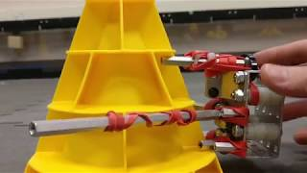

**Choice:** Claw

We have decided to pick the claw as it Is the only intake that pick up both mobile goals and cones and it is essential that robot can do that. Our next best choice would be the cylinder intake and we would use it if we had two separate lifts.

**Pros:**

* Simple
* Reliable

**Cons:**

* Can’t lift up mobile goal
* Uses two motors
* Wires down to claw

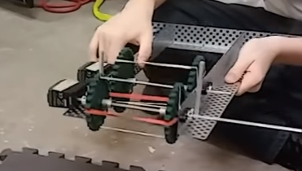

### Passive intake

**Pros:**

* Can have mobile goal manipulator added
* Strong
* Reliable

**Cons:**

* Uses two motors
* Wires down lift.

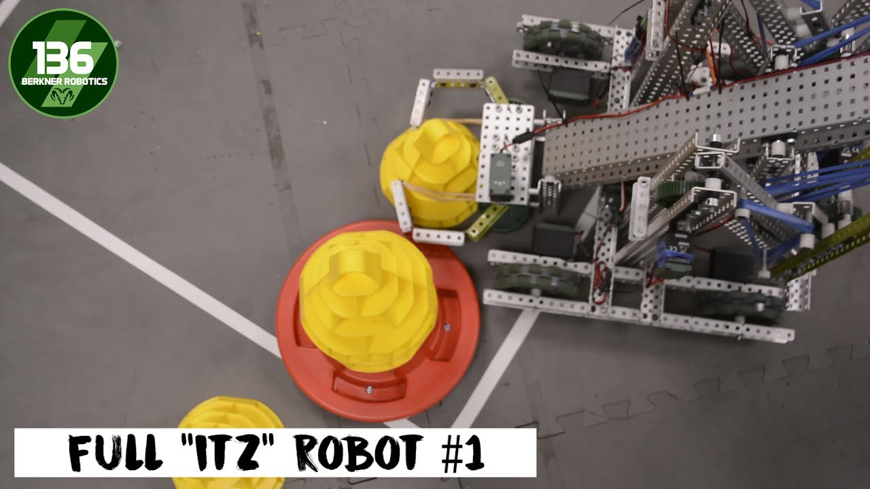

# Intake design considerations

## Intake Type

Now what we had picked the drive and lift we must decide what type of lift manipulator want to use. We want something strong and light that can lift both mobile goals and cones

### Claw

### Cylinder intake

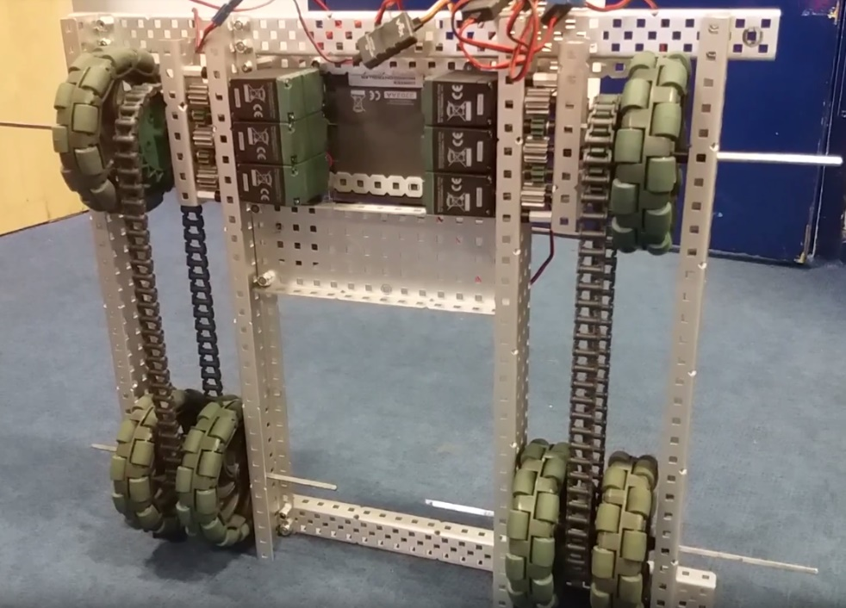

Logged by Robbie Buxton

19/06/2017 – 18:23

**Future Changes:**

* Fix axle squeaking problem (move or lubricate)
* Move motor and gear system inwards by one notch
* Build to full design

**Changes Made:**

* N/A – Initial build

**Overview:**

This is the first version of the base and robot. It is built to a slightly smaller specification than we will use in the end due to not wanting to commit to cutting metal before we are certain with the design. At the moment, we are experimenting with a drive train system. This is because we found in the prior season that if not on a drive chain motors tend to obstruct mechanisms and can cause intake problems. We have also decided to use at least 6 motors on our base due to the fact that we do not need any more than 5 motors for our lifting system; 2 on the primary lift, 2 on the secondary and 1 on the claw. After testing the system briefly, we have come to the conclusion that general system works however some of the gear axles need their position to be slightly tweaked as they are causing squeaking. We also think that it would be beneficial to try and move the motors and the gear system in by one bar to try and reduce space.

**Specification:**

* 6 Motor HS drive
* 2 drive chains
* 6 wheels
* Aluminium structure

**Dimensions:**

* 17.5″ x 15″

Robot v1.0

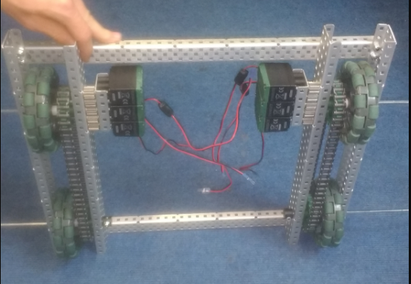

Logged by Sam Poirier

20/06/2017 – 16:14

**Future Changes:**

* Axles need to be cut and secured
* Need to add a plate for mounting the lifting device/intake

**Changes Made:**

* Motors have been moved from the primary frame to a secondary mounting
* 2 internal wheels have been removed

**Overview:**

This is the second version of our robot. With the first prototype, we found that too much space was being wasted allowing all the motors to be blocked together, reducing the space in the centre of the robot which we needed for our intake device. We decided to make the motor block a modular attachment. We will most likely keep this basic design for the next versions of the robot however it requires some additions and changes such as securing axles and the addition of a mounting plate for our lifting device.

We removed two wheels as doubling them up was unnecessary and only served to add redundant weight to the robot.

**Specification:**

* 6 Motor HS drive
* 2 drive chains
* 4 wheels
* Aluminium structure

**Dimensions:**

* 17.5″ x 15″

Robot v1.02

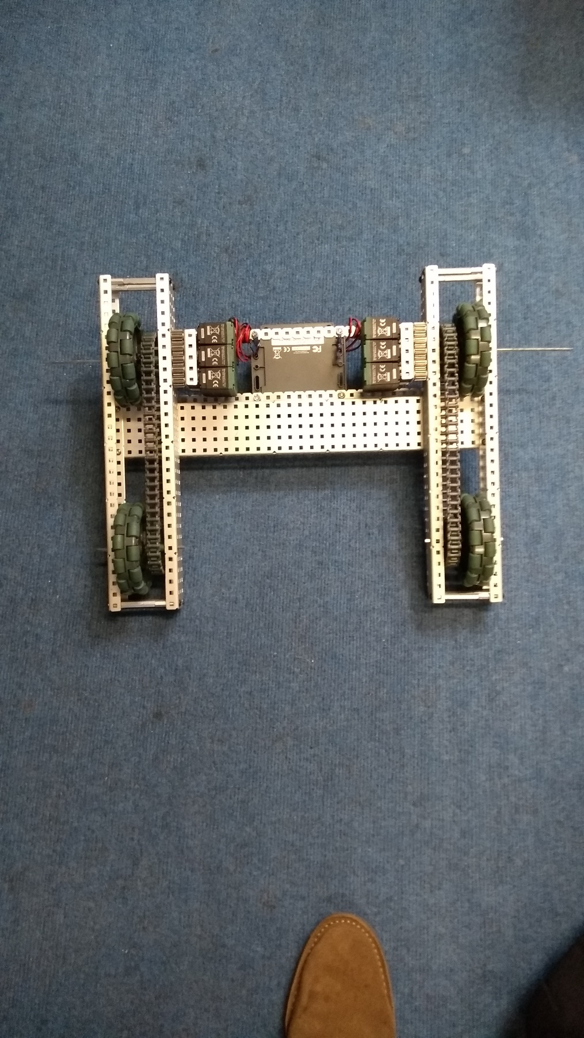

**Overview:**

This is only as small change to the prior version of the robot. None of the internal mechanism have been changed as the focus of this version was to modify the base to have a strong but light structure. Each of the wheel sections are now independently held together by stand-offs meaning that access to the wheel areas for modification of the mechanisms or structure is easier. The temporary structs on each end of the robot have also been replaced with a single bar across the middle allowing the base to be able to intake objects in the front without them being caught.

Logged by Robbie Buxton

21/06/2017 – 16:38

**Future Changes:**

* A battery mount needs to be built, with the ability to swap out charged and uncharged batteries with ease
* The mounting plate on the top needs to be added

**Changes Made:**

* The method that the chassis is held together by has been changed
* Basis for mounting plate added
* Shaft collars added to lock wheels into the robot

**Specification:**

* 6 Motor HS drive
* 2 drive chains
* 4 wheels
* Aluminium structure

**Dimensions:**

* 17.5” x 15”

Robot v1.03

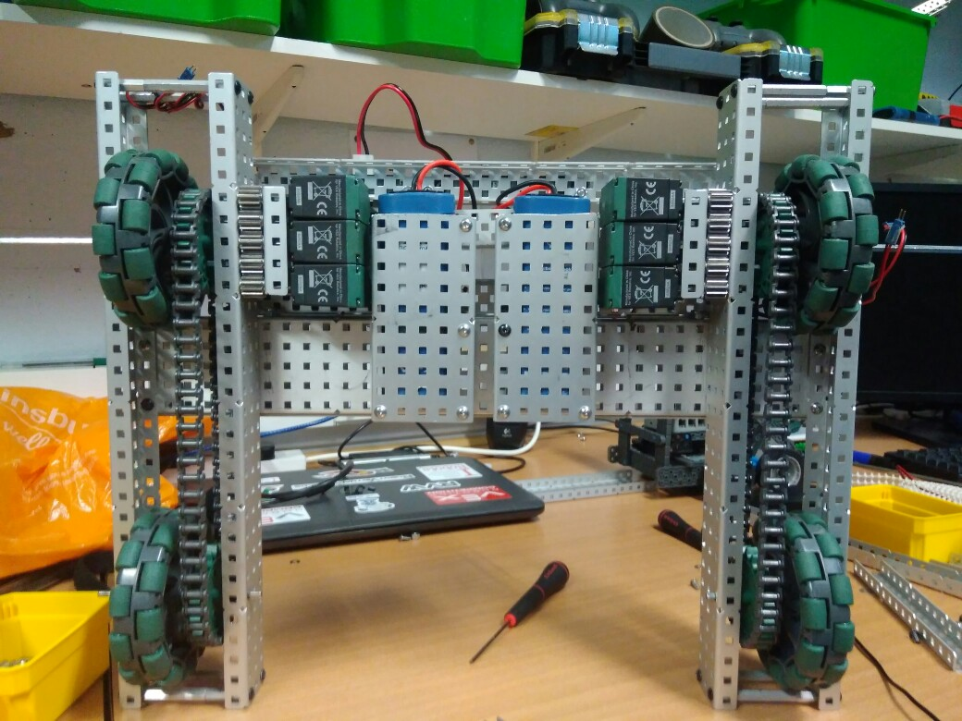

**Specification:**

* 6 Motor HS drive
* 2 drive chains
* 4 wheels
* Aluminium structure

**Dimensions:**

* 17.5” x 15”

**Changes Made:**

* Added 2 battery mounts
* Added the front mounting plate for the lift mechanism
* Securely mounted the brain and power extender
* Added a method to secure the batteries when the robot is active

**Future Changes:**

* Cable Management!
* Start work on the primary and secondary lift

Robot v1.04

**Overview:**

The next addition is a device for storing batteries. A large 10 x 5 C section is suspended by 3 stand-offs. The batteries can be easily slipped in and out then secured by tightening a securing bar. The batteries are then plugged into two cable extenders that are plugged in respectively to the cortex and the power extender. We have also added a large plate for the primary lift to be mounted upon. The cortex mounting has been replaced with a more reliable system and a power extender has been added. After everything is wired in the base will be fully functioning.

Logged by Felix Black

28/06/2017 – 17:12

Robot v1.05

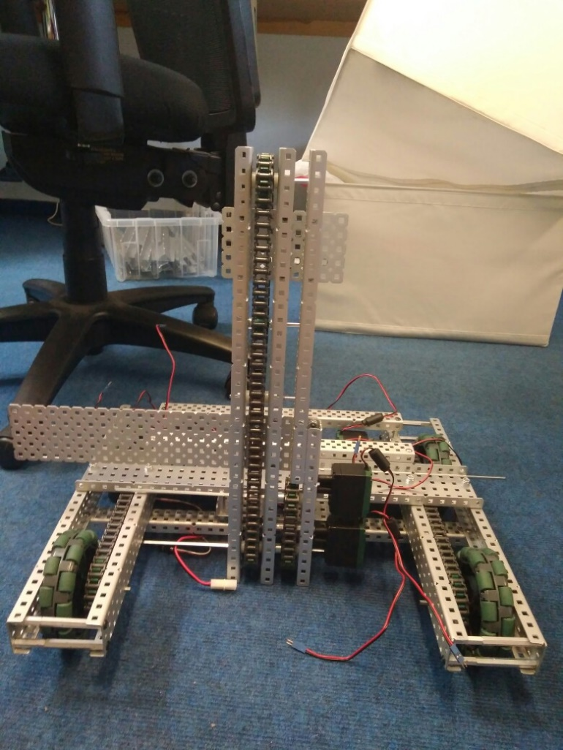

**Specification:**

* 6 Motor HS drive
* 2 drive chains
* 4 wheels
* Aluminium structure
* 2 motor lift

**Dimensions:**

* 17.5” x 15”

**Changes Made:**

* Built the first prototype of the lift mechanism (not yet attached)

**Future Changes:**

* Remake the first stage using nyloc nuts
* Add two more lift stages
* Attach first stage to robot
* Add two more motors to lift

**Overview:**

For this version of the robot we have had our first attempt at building the first stage of our 3-stage elevator lift that we plan to use for picking up cones and mobile goals. We made the first prototype version using non-nyloc nuts in order to ease quick changes so it must be remade with them to increase the strength. We also need to create two more stages of lift and add two more motors so the lift is a four-motor lift, increasing the torque, allowing for greater weights to be lifted. After that we need to attach it to the robot. Normally we would make the claw first but due to the fact that our field elements have not arrived we have decided to build the lift first.

Logged by Sam Poirier

04/07/2017 – 17:19

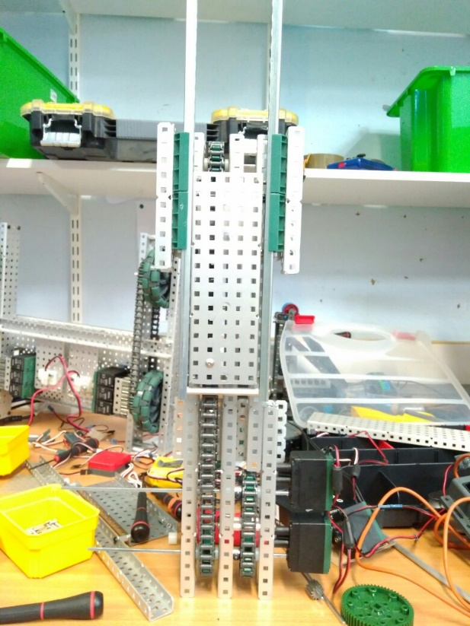

**Changes Made:**

* Remade the first stage with nyloc bolts
* Added mount for second stage
* Attached second stage

**Specification:**

* 6 Motor HS drive
* 2 drive chains
* 4 wheels
* Aluminium structure
* 2 motor lift
* 2 stage lift

**Dimensions:**

* 17.5” x 15” x 17.5”

Robot v1.06

**Overview:**

For this version of the robot we have remade the first prototype version of the lift. It is now held together with nyloc bolts meaning it is far stronger. We have also added a second stage to the lift. The second stage is held in the mount on the first stage and is fastened to the chain allowing it to move up and down in the y axis. To make the third stage of the lift we need two 12 tooth sprockets so we wait for them to arrive we must keep it to two stages. We also tested the strength of the lift using a newton meter finding it could lift up to 3kg. this means that when we add two more motors it should be able to lift upwards of 6kg. The crucial factor is whether or not the chain inside the lift could support the weight. The tensile strength provided on the website states that the chains is approximately 22.5 kg so we should be fine, however we will run our own tests to confirm this.

Logged by Robbie Buxton

05/07/2017 – 15:49

**Future Changes:**

* Add a third stage
* Add 2 more motors
* Attach to robot

Robot v1.20

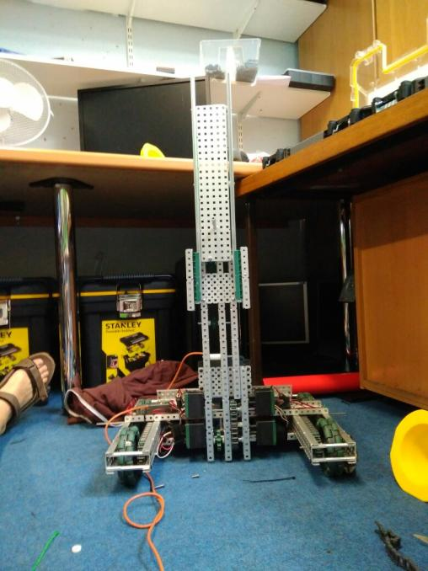

**Specification:**

* 6 Motor HS drive
* 2 drive chains
* 4 wheels
* Aluminium structure
* 4 motor lift
* 2 stage lift

**Dimensions:**

* 17.5” x 15” x 17.5” when not extended

**What needs to be changed:**

* Fix lift problem
* Build the claw

Logged by Sam Poirier

09/07/2017 – 12:55

**Overview:**

Finally, we have mounted the lift onto the base of our robot. After that we mounted the cortex and the power extender which we plugged the lift and drive into. We also finally got around to improving the cable management of our robot. After switching everything on we found the robot was balanced well and the drive worked perfectly however the lift was having problems. We found the lift would go up perfectly however would jitter and shudder when going downwards. We could not identify the problem today however we plan to work out what is causing the problem and fix it.

**Changes Made:**

* Attached lift to base
* Added 2 more motors to lift
* Mounted cortex and power extender
* Wired up the robot

Robot v1.21

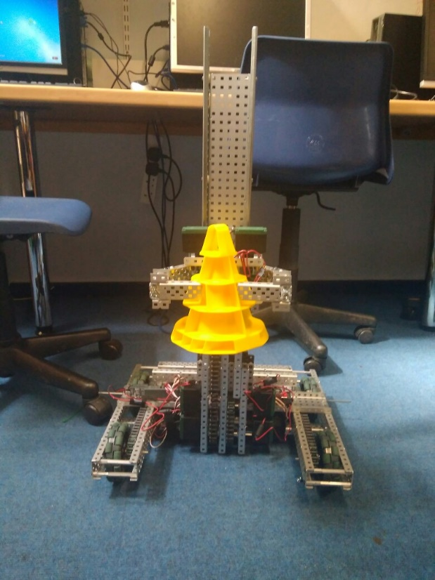

**Specification:**

* 6 Motor HS drive
* 2 drive chains
* 4 wheels
* Aluminium structure
* 4 motor lift
* 2 stage lift
* 2 motor claw

**Dimensions:**

17.5” x 15” x 17.5” when not extended

Logged by Felix Black

13/07/2017 – 16:29

**Overview:**

We have managed to fix the problem affecting the movement of the lift downward. For greater detail have a look at the 1st document of problems we encountered on page (###). We have also added a claw meaning that our robot is now able to pick up cones and stack them. However, it does not do this flawlessly and needs some improvement. We also need to add a third stage to the lift to increase the speed of lifting and to increase the maximum height but cannot do this until the parts arrive.

**Future Changes:**

* Improve claw
* Add a third stage

**Changes Made:**

* Fixed lift problem
* Added claw

Robot v1.22

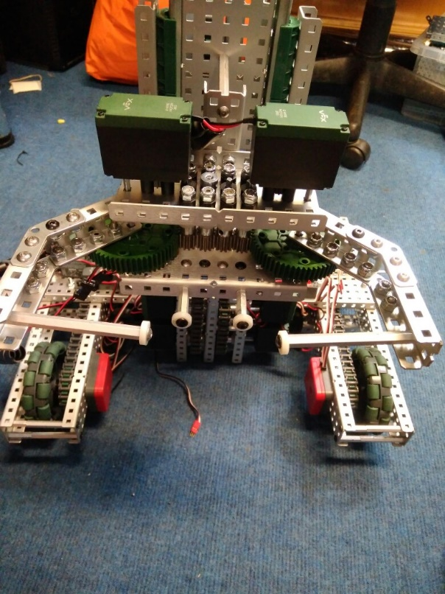

**Specification:**

* 6 Motor HS drive
* 2 drive chains
* 4 wheels
* Aluminium structure
* 4 motor lift
* 2 stage lift
* 2 motor claw

**Dimensions:**

17.5” x 15” x 17.5” when not extended

Logged by Robbie Buxton

14/07/2017 – 13:46

**Overview:**

The latest changes we have made is an overhaul to the claw, making the transition to using standoffs as the main method of grip. We found these to be better as they are smaller meaning that the claw is more likely to get into the cone and get a stable grip. We have also added two static standoffs to improve the grip of the claw

**What needs to be changed:**

* Add a third stage
* Wire up shaft encoders

**Changes Made:**

* Improved claw
* Added shaft encoders

Robot v1.23

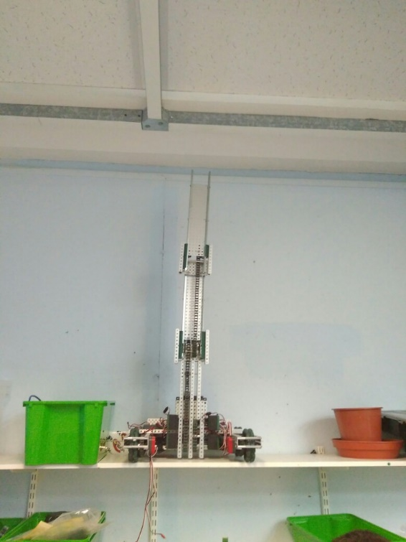

**Specification:**

* 6 Motor HS drive
* 2 drive chains
* 4 wheels
* Aluminium structure
* 4 motor lift
* 3 stage lift
* 2 motor claw

**Dimensions:**

* 17.5” x 15” x 17.5” when not extended

Logged by Robbie Buxton

17/07/2017 – 16:30

**Overview:**

The parts we needed to make the third stage finally arrived (two 12 tooth sprockets) today so we could complete the third stage of lift. The linear action works very well however it a bit lop-sided which is something we will need to fix. After we mount the claw the core robot will be finished and we will be able to focus on fine tuning the robot.

**Future Changes:**

* Plug in shaft encoders
* Make lift straight
* Mount claw

**Changes Made:**

* Added third stage

Robot v1.24

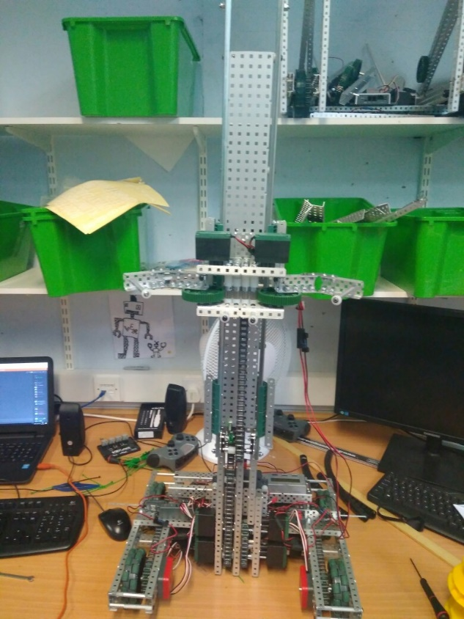

**Specification:**

* 6 Motor HS drive
* 2 drive chains
* 4 wheels
* Aluminium structure
* 4 motor lift
* 3 stage lift
* 2 motor claw

**Dimensions:**

* 17.5” x 15” x 17.5” when not extended

**Overview:**

For this version of the robot we have remounted the claw. We also managed to fix the problem with the robot being slanted by loosening then tightening all the screws holding the lift in place. We have found that when the robot starts to lift heavier weights the main chain in the lift begins to skip gears. This is a huge problem if we cannot fix it as it basically invalidates the main idea behind the design; being a multi-role robot able to lift mobile goals in addition to cones on the same lift. As well as fixing that problem we also need do some cable management and plug the shaft encoders in.

Logged by Felix Black

18/07/2017 – 16:12

**Future Changes:**

* Plug in shaft encoders
* Fix chain skipping problem
* Cable management

**Changes Made:**

* Mounted claw
* Straightened lift mechanism

Robot v1.25

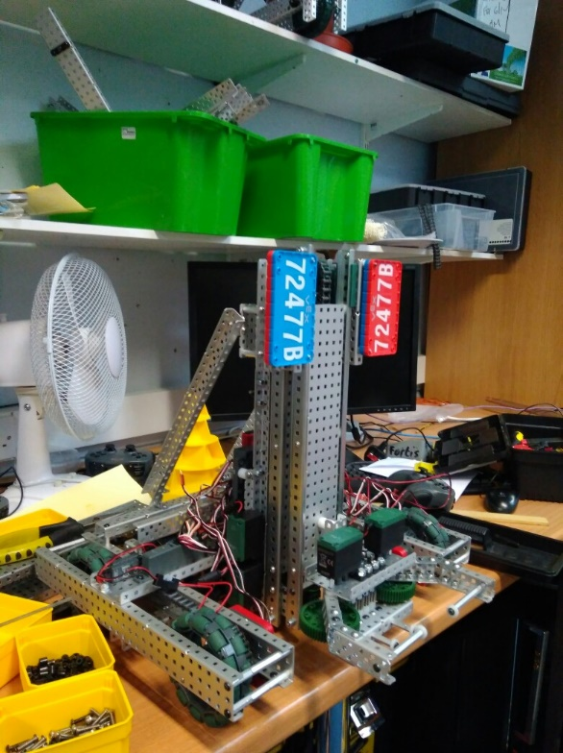

**Specification:**

* 6 Motor HS drive
* 2 drive chains
* 4 wheels
* Aluminium structure
* 4 motor lift
* 3 stage lift
* 2 motor claw

**Dimensions:**

* 17.5” x 15” x 17.5” when not extended

Logged by Sam Poirier

19/07/2017 – 17:06

**Overview:**

Most of the time spent this session was focused on trying to fix the chain skipping problem which we finally fixed. For more details on the problem have a look at the 2nd problem document on page (###). Along with fixing that major problem we also experimented with adding two support struts behind the lift to give it greater stability. They turned out to be quite useful so we have made them part of the key structure. We also located a place to initially mount the number plates. It is important that it is easy to swap out the colours for when we enter a competition. The place they currently reside looks nice however is not very practical as it only shows the robots number from a single direction so we will need to move them to opposing sides of the robot.

**Future Changes:**

* Plug in shaft encoders
* Cable manages
* Put number plates in a better position

**Changes Made:**

* Fixed chain skipping problem
* Added number plates
* Added two support bars

Robot v1.26

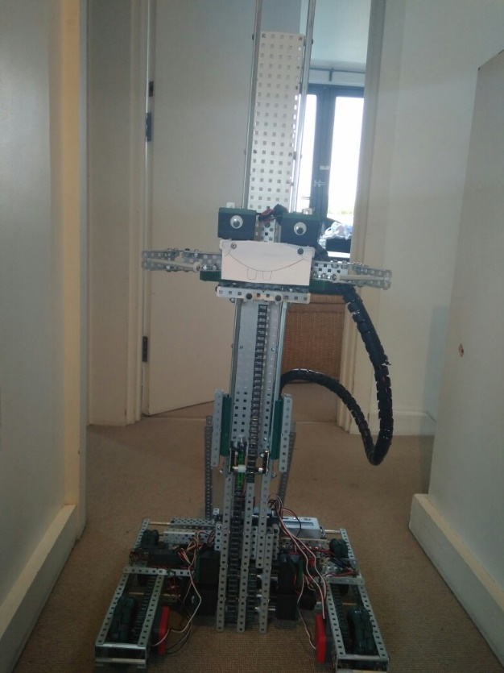

**Specification:**

* 6 Motor HS drive
* 2 drive chains
* 4 wheels
* Aluminium structure
* 4 motor lift
* 3 stage lift
* 2 motor claw

**Dimensions:**

* 17.5” x 15” x 17.5” when not extended

Logged by Sam Poirier

20/07/2017 – 19:51

**Overview:**

Most of the day was spend transporting the robot from school to Robbie’s house because we have decided to work on it over the summer there, however we did get some word done on the robot. The first thing we did was to properly secure all the cables on the robot to stop them getting stuck in resulting in a complete breakdown. We also put some casing around the main wire from the cortex to claw so it doesn’t get suck on parts of the robot and get pulled out with lifting. We also added two line trackers for later in the season when we start to work on autonomous allowing for a more accurate and intelligent program and finally plugged in all the peripherals so we have no loose wires.

**Future Changes:**

* Put number plates in a better position
* Redesign claw

**Changes Made:**

* Added cosmetics
* Done cable management
* Added two-line tracks
* Plugged in peripherals

Robot v1.27

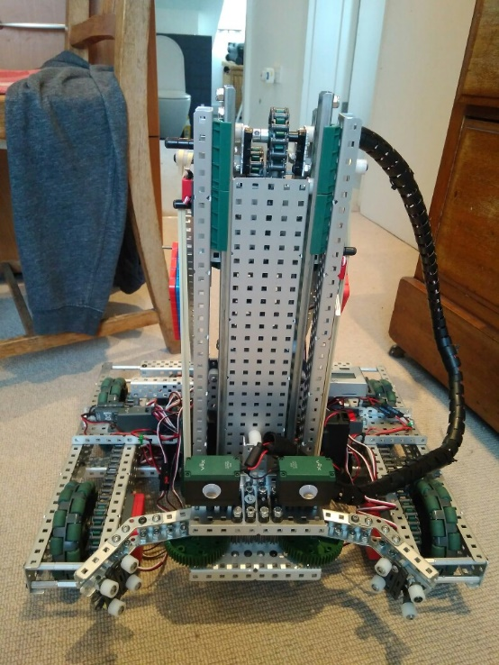

**Specification:**

* 6 Motor HS drive
* 2 drive chains
* 4 wheels
* Aluminium structure
* 4 motor lift
* 3 stage lift
* 2 motor claw

**Dimensions:**

* 17.5” x 15” x 17.5” when not extended

Logged by Robbie Buxton

30/07/2017 – 20:36

**Overview:**

The robot is now nearly ready to enter the full programming phase as most of the engineering work is complete. The first things we added today were two limit switches allowing us to program the lift to cut out at the minimum and maximum heights and an integrated motor encoder enabling us to implement PID control to the lift. We also added a Potentiometer to the claw so we can later also implement PID control there. The next thing we did was to rebuild the claw. We removed the standoffs and replaced them with spacers on tank tread which are far better at gripping the cone. We still need to add the module to the claw to manipulate mobile goals however since they still haven’t arrived yet we need to wait until they arrive before we can accurately do that. The final thing we did today was to add rubber bands to assist the lift. This allows it to be faster and stronger when going upwards which is essential as our lift is multifunctional and needs to be able to lift a whole stack.

**What needs to be changed:**

* Add mobile goal manipulator element to claw
* Program PID control
* Add stabilisers

**Changes Made:**

* Added integrated motor encoders
* Added two limit switches to the lift
* Remade the claw
* Put number plates in a better position
* Added elastic bands to assist lift.
* Added Potentiometer to the claw

Robot v1.28

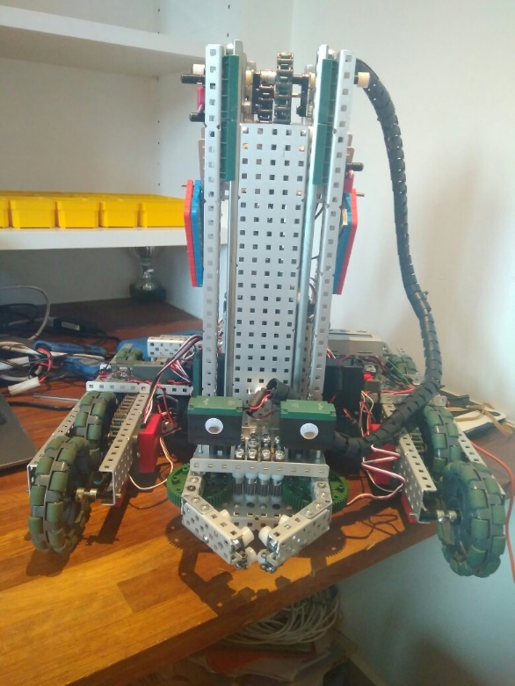

**Specification:**

* 6 Motor HS drive
* 2 drive chains
* 6 wheels
* Aluminium structure
* 4 motor lift
* 3 stage lift
* 2 motor claw

**Dimensions:**

* 17.5” x 15” x 17.5” when not extended

Logged by Sam Poirier

02/08/2017 – 11:54

**Overview:**

For this version of the robot we managed to fix two problems with one change. The first problem was that the robot was unstable and very prone to falling over. The second problem is that we realised is that if the robot tries to go over the bar into the 10 point zone the bottom of the lift will get caught on the bar and will result in the robot getting stuck. We think we fixed both these problems by moving the front wheels into the centre of the robot and added a new pair of free-wheeling wheels at the very front to increase the size of the base of the robot therefore increasing stability. By moving the wheels to the centre when the robot passes over the bar the wheels should also be touching bar instead of the lift stopping it getting stuck. We have not been able to test this however because our field elements still have not arrived in the UK.

**Future Changes:**

* Add mobile goal manipulator element to claw
* Program PID control

**Changes Made:**

* Added extra pair of wheels for stability
* Moved front wheels to the middle

Robot v1.29

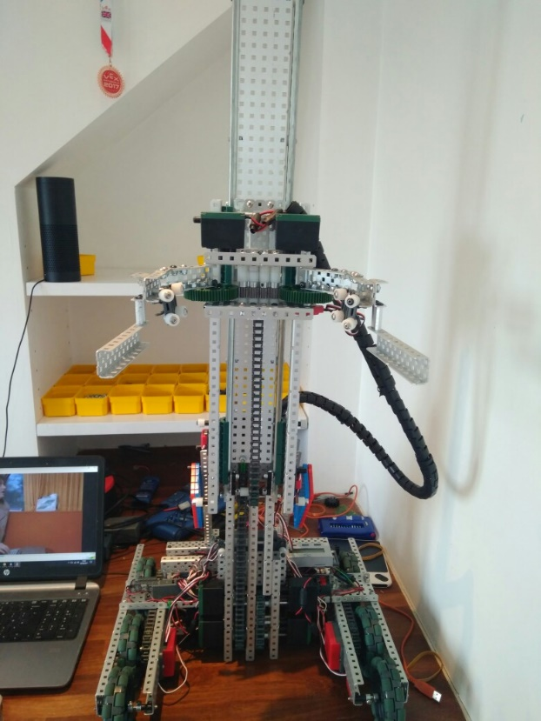

**Specification:**

* 6 Motor HS drive
* 2 drive chains
* 6 wheels
* Aluminium structure
* 4 motor lift
* 3 stage lift
* 2 motor flip down claw

**Dimensions:**

* 17.5” x 17.5” x 17.5” when not extended

Logged by Felix Black

04/08/2017 – 16:03

**Future Changes:**

* Program PID control
* Add a way to hold up claw before the match starts

**Overview:**

After we called up our Vex parts supplier we found out that our field elements would not be arriving for at least another month. We decided to cut out a piece of paper in the exact dimensions of the mobile goal found in the field appendixes to try and prototype a mobile goal manipulator. After building the extension to the claw which we are certain will be able to pick up the mobile goal we realized that the claw was too big and was out of the size limit. After deciding that making it smaller wouldn’t be a very good idea we decided to make our claw fold up at the begging. We did this using a hinge. We now need to find out a way to hold the claw up before the match starts.

**Changes Made:**

* Added mobile goal manipulator
* Made the claw flip down

Robot v1.30

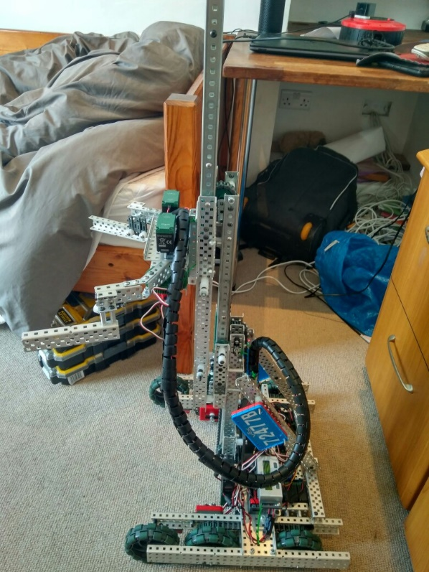

**Specification:**

* 6 Motor HS drive
* 2 drive chains
* 6 wheels
* Aluminium structure
* 4 motor lift
* 3 stage lift
* 2 motor flip down claw
* 5.5kg weight

**Dimensions:**

* 17.5” x 17.5” x 17.5” when not extended

s

Logged by Robbie Buxton

25/08/2017 – 10:09

**Future Changes:**

* Program PID control
* Fix drive problem
* Add limiter switches again

**Overview:**

Over the last 20 days we had a bit of a break from working on the robot as some team members had holidays and it was not possible to organize build sessions. The focus of this update was reworking the rubber band system so we could reliably lift the mobile goal as we were having trouble with it earlier. We moved the primary rubber band system closer together and added a counter rubber band system to hold the robot inside the size limit at the begging of the match. The counter rubber band system is released by moving the robot forward as it is attached to a rotating lock bar on the wheel axle. We also extended the bar used to stop chain skipping under both chains. While adjusting the rubber band systems we also temporary removed the limiter switches. One of the problems with the robot that we noticed is that the drive shorts out quickly when driving. We fiddled with the drive to try and reduce friction but that did not seem to have much effect. We need to fix this quite urgently because it renders the robot nearly useless.

**Changes Made:**

* Reworked rubber band system on the lift
* Added counter rubber band system
* Added rubber band releases
* Minor adjustments inside drive
* The bar used to stop chain skipping has been expanded to both chains
* Temporarily removed limiter switches

Robot v1.31

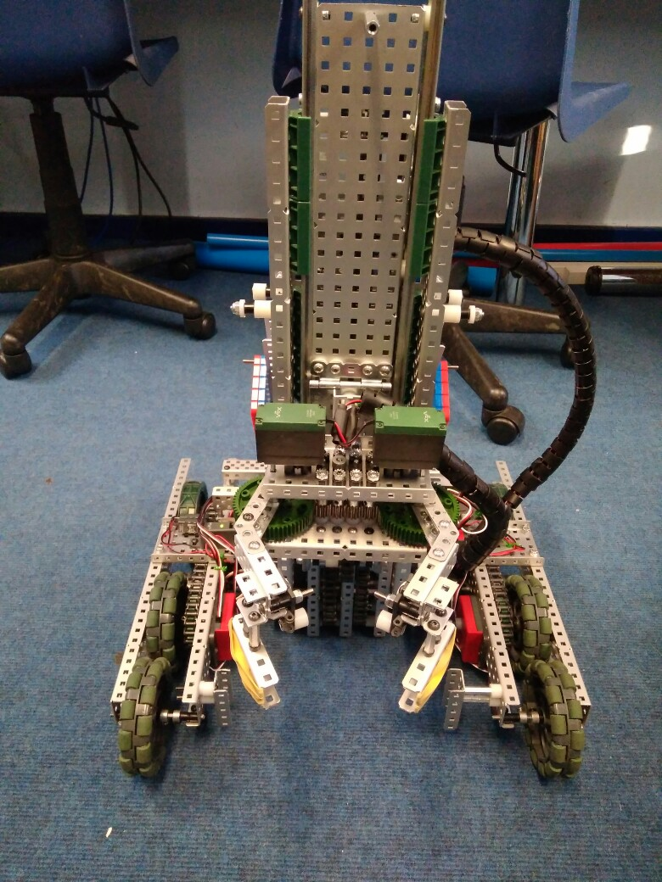

**Specification:**

* 6 Motor HS drive
* 2 drive chains
* 4 omni – 2 friction wheels
* Aluminium structure
* 4 motor lift
* 3 stage lift
* 2 motor flip down claw
* 5.5kg weight

**Dimensions:**

* 17.5” x 17.5” x 17.5” when not extended

Logged by Sam Poirier

15/09/2017 – 11:13

**Future Changes:**

* Program PID control
* Add limiter switches again

**Overview:**

There hasn’t been much visible progress over the last 20 days due to the fact that team has started school again and has not have much time available to spend working on vex. However, we did manage to get a few things fixed. We switched out the back omni-wheels for traction wheels to be assist the robot going over the bars. We also managed to fix the drive problem (as shown in problem log 3 on page #). The last thing we did was adjust the mogo (mobile goals) section of the claw to be better at picking up mogos by shortening it and by adding rubber bands for grip.

**Changes Made:**

* Fixed drive problem
* Moved over to pros for software development
* Replaced rear wheels with friction wheels
* Rebuilt claw

Problem 1: Lift problem

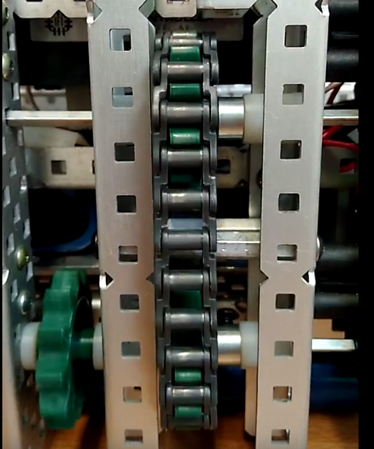

**Description:**

After completing the two stages lift and mounting to our robot we found that there was a problem. When the lift pulled the chain upwards It worked perfectly. However when the chain was pulled down it jittered and shook.

By Robbie Buxton

14/7/2017 – 13:46

**Process:**

Initially we though the problem was doing with motors being on differing gear ratios as we had had to switch the internals of some off the motors out. The first thing we did was take the lift apart and replace all four motors with fresh ones to be safe. This resulted in the problem having a lesser effect but still being present. We then decided that the problem must have something to do with chain tension as when the direction of the lift changed the tension of the chain also appeared to change. After messing with the tension of the chain for a while we concluded that this wasn’t the source of the problem. At this point we decided to manually reverse the ports of motors to see if this would have any effect. Surprisingly this did. The direction the motors were struggling in reverse. We then concluded that the problem must be software based. We all have a look at the code but we could not figure out the source of the problem. In the end, we went onto the “Vex teams of the world” discord channel and asked if someone might have a look at our code. User Geo#1066 kindly gave us a hand and showed us what was the problem with our code. We tested the latest version of the code and the problem was fixed.

**Cause and solution:**

**Software:**

One of the else statements always triggered as the buttons were never pressed at the same time. Putting them in one statement meant that it was only if neither were pressed they'd stop

**Probable causes we thought at the time:**

**Hardware:**

* Motors on differing gear ratios
* Faulty motors
* Chain tension problems

**Software:**

* Problem with individual motor directions when reversing direction of whole lift

**After:**

**Before:**

## Code before and after

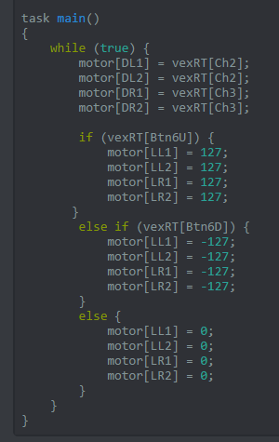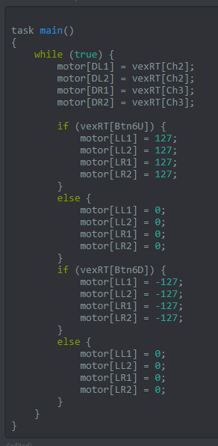

Problem 2: Chain problem

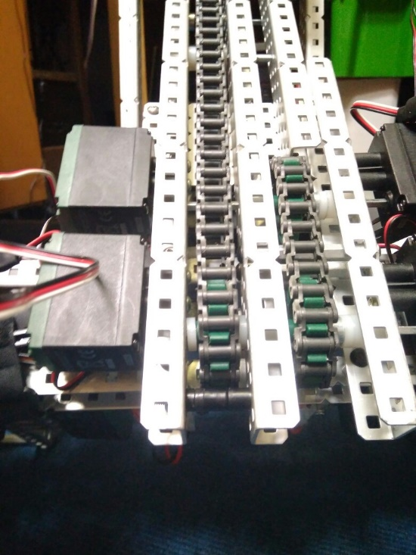

**Description:**

We found that when attempting to lift heavy weights with our robot the lift struggled and the chain skipped sprockets rather than lift the object.

By Robbie Buxton

19/7/2017 – 17:23

**Process:**

Initially we though the problem was mainly to do with the chain being not tense enough. To solve this problem with the recommendation of Luke from VEXU team VIRUS who we have been in communication with through the VEX UK discord channel we took one of the section of the chain from the primary chain and replaced it with two zip ties. This allowed us to get the tension exactly right. This helped however it did not solve the problem. The next step we took towards fixing the problem was changing how the chain was attached to each stage. The main method we were using was a screw through the chain screwed tight. This worked as a method of securing the chain however resulted in the chain being pulled out towards the next stage. To fix this we added standoffs to the screws which resulted in the chain being pulled out less than before. This still did not fix the problem. We had more experiments with the chain and we saw that when the motor was running the chain became very loose around the gear. We decided to put a standoff under the primary drive sprocket which stopped the chain from becoming lose. This turned out to solve the problem.

**Cause and solution:**

**Hardware:**

We installed a single long screw with lots of spacers on it below the primary lift drive sprocket. This is highlighted in the picture above. The way this device works is that because of its proximity to the drive gear it forces the gear to stay on the sprocket always therefore stopping the chain from being able to skip. At the moment, it is only on the primary lift gear as no other gears have a problem with chain skipping.

**Probable causes we thought at the time:**

**Hardware:**

* Chain tension too low
* Sprockets are too small
* Bad attachments to stages

**Software:**

N/A

Problem 3: Drive problem

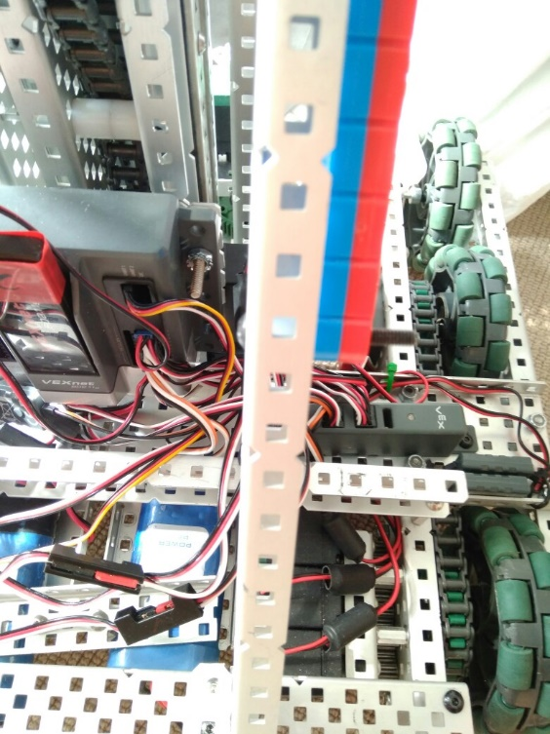

**Description:**

We found that when driving the robot around on a flat surface it would overload the motors on the drive and the robot would stop.

By Robbie Buxton

19/7/2017 – 17:23

**Process:**

The first thing we did was take apart the drive and start putting flat bearing blocks on the drive shaft because we had forgot to when we initially built the drive. This reduced friction however did not fix the problem (we were going to do this at some point anyway). Our next approach was to buy lubrication and apply it to the drive block however this still did not solve the problem. At this point we were out of ideas so we went the Vex UK discord where Joel from 4941 (Vex Alumni) suggested that we move some of the drive onto our power expander. We did this and it fixed the problem.

**Cause and solution:**

**Hardware:**

We switched the ports of the drive from all being in the main cortex to having the left side of the drive in the power expander, this resulted in us also doing the same thing lift however moving half of the motors over to the cortex. This fix suggests that problem must have been that the drive was drawing too much power from a single source causing the robot to overload.

**Probable causes we thought at the time:**

**Hardware:**

* Too much friction between gears
* Wheels were rubbing against frame causing friction
* Bad/dead motors

**Software:**

* Motors being programmed incorrectly